Task-13[Elastic Load Balancer]

**1) Configure Classic Load balancer.**

Launched the two ec2-instances with httpd service

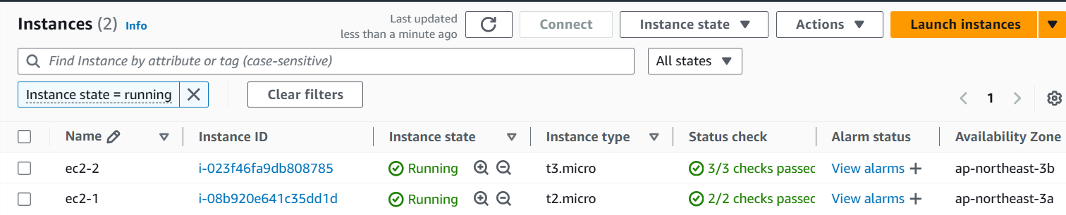

Coonecting to the httpd with both the public ips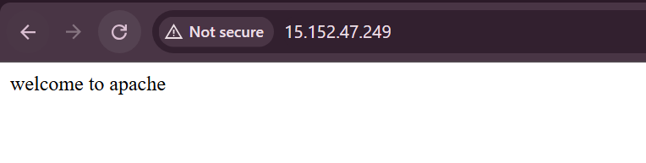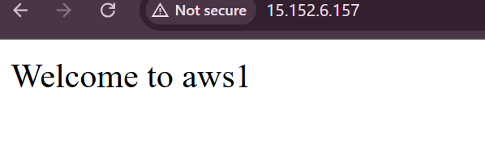

Lauching one Classic load balancer with the two target instances

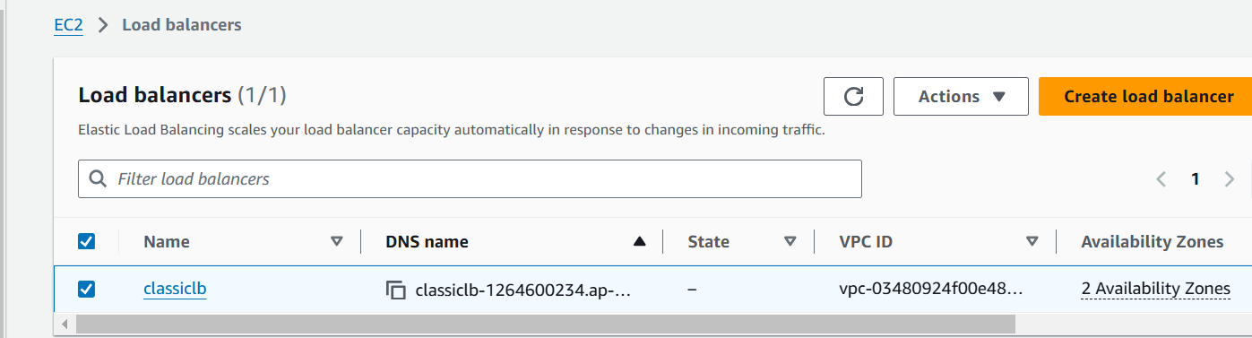

Copy the dns name and check the connectivity in the browser

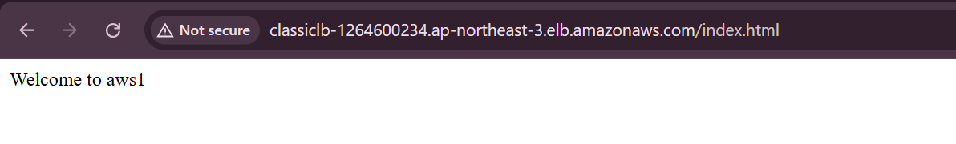

Refresh the browser

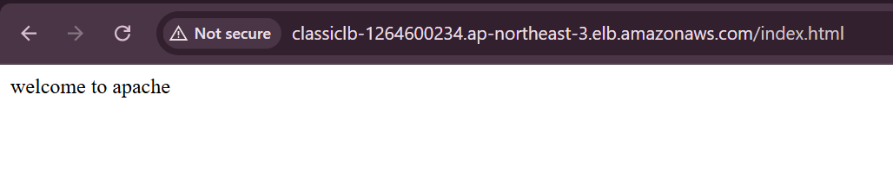

Can also get with dns[as we specified in listerner port]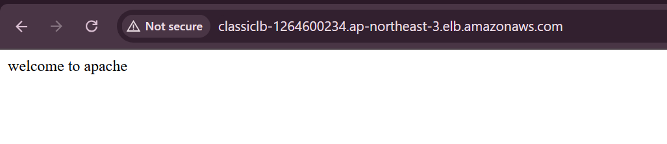

**2) Configure Application Load balancer.**

Created application loadbalancer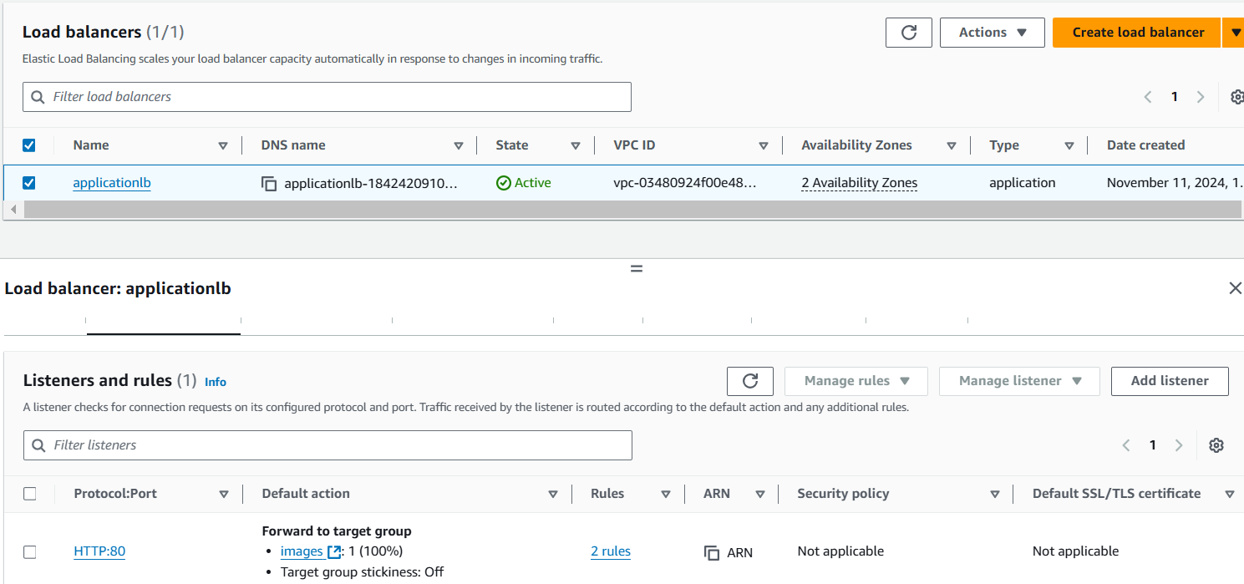

Created one rule that /images* should open the browser

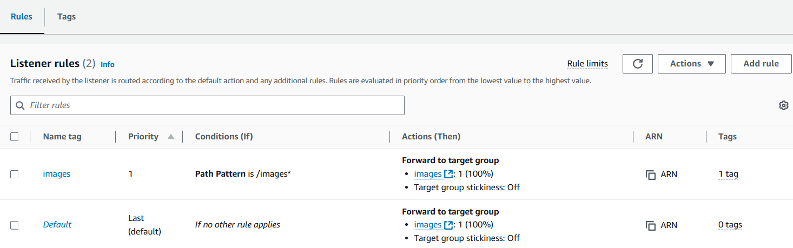

We can check in the output

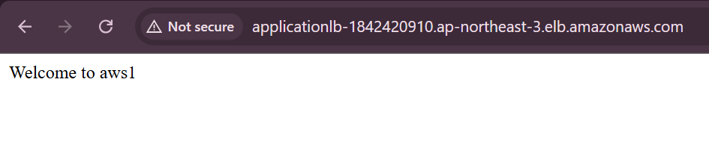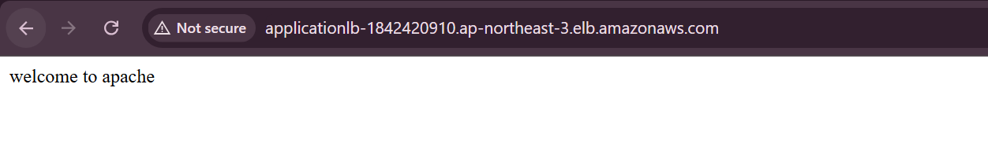

We can also check the images prefix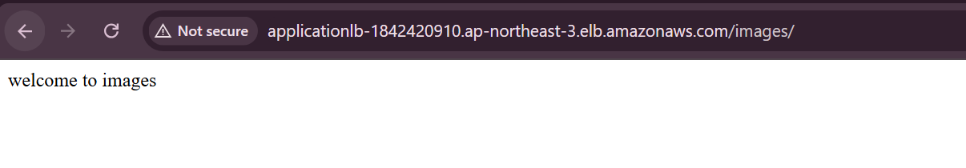

**3) Configure Network Load balancer.**

created one network load balancer with the target groups attached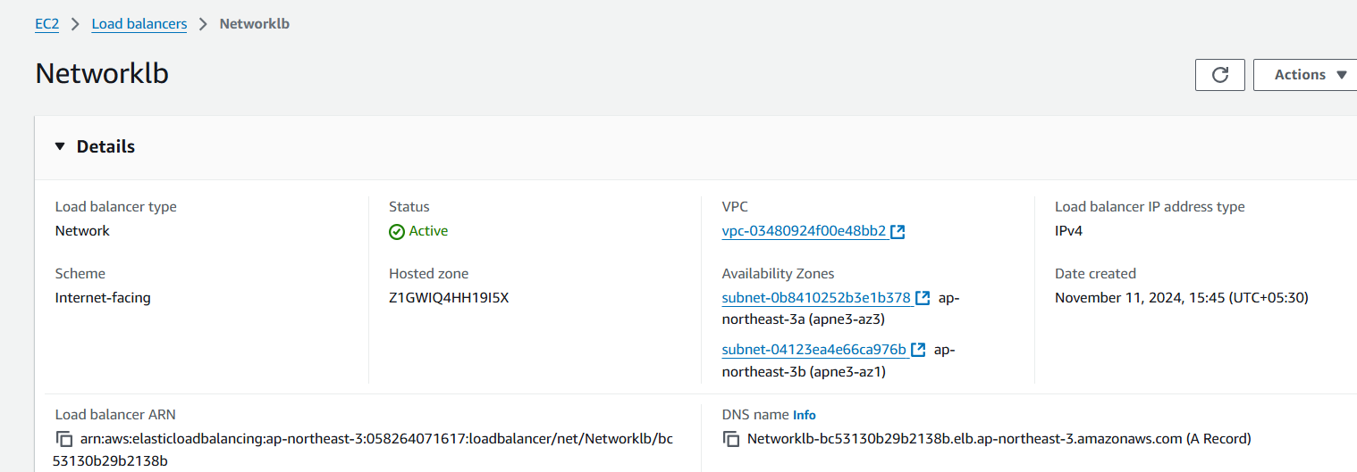

target groups are the instances that we created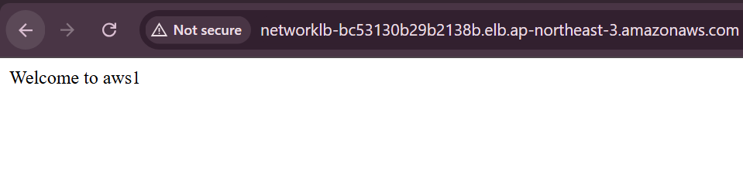

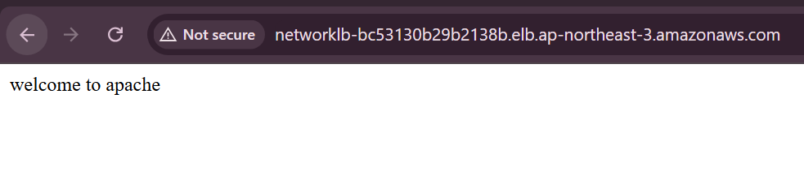

**4) Attach SSL for application load balancer.**

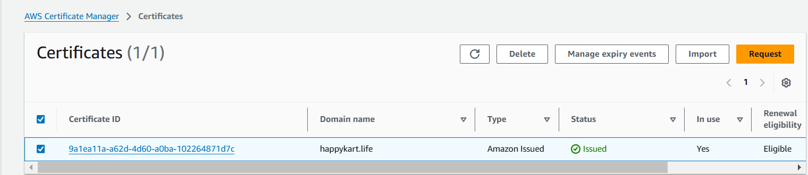

Added SSl certificate to load balancer 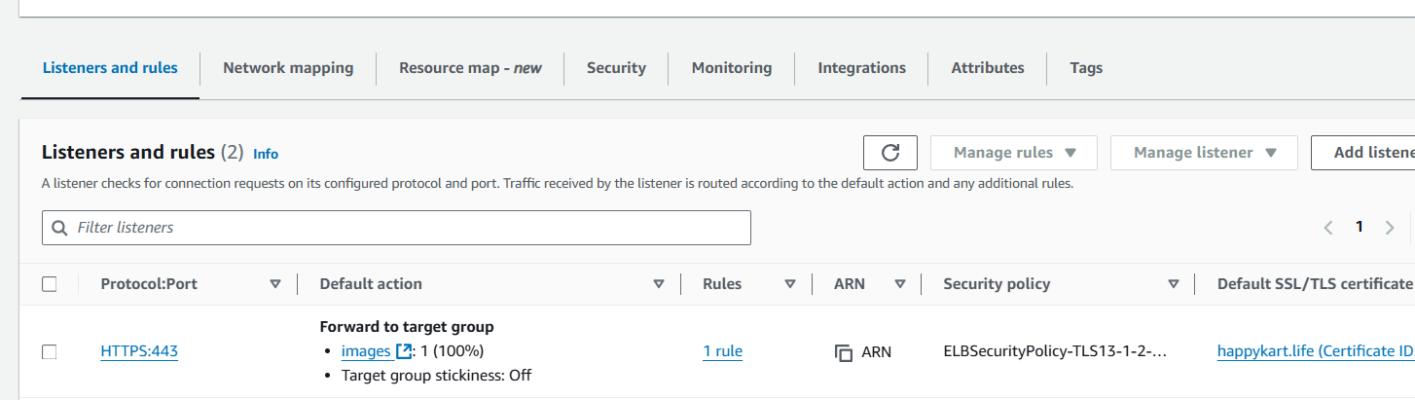

**5) Map Application load balancer to R53.**

Go to r53

Click create record

In record

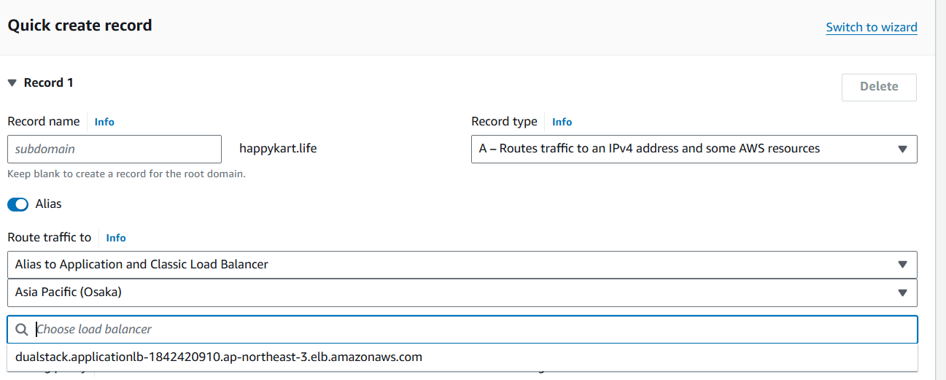

Now we see the output

Instance1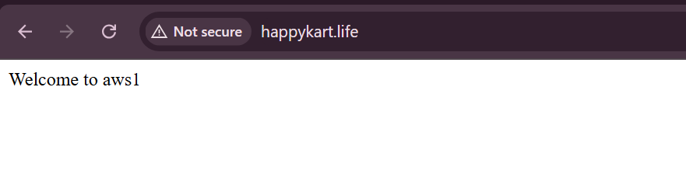

Refresh the page

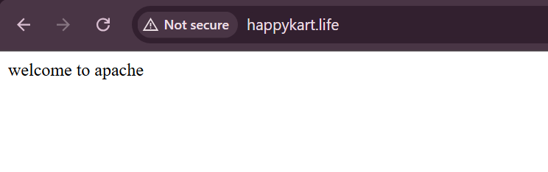

**6) Push the application load balancer logs to s3**.

In Application load balancer >access logs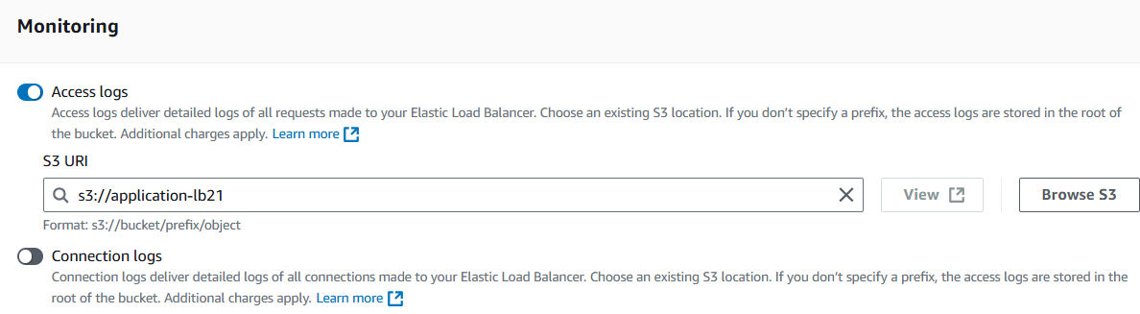

Before, created a bucket with a policy [load balancer access logs to s3] 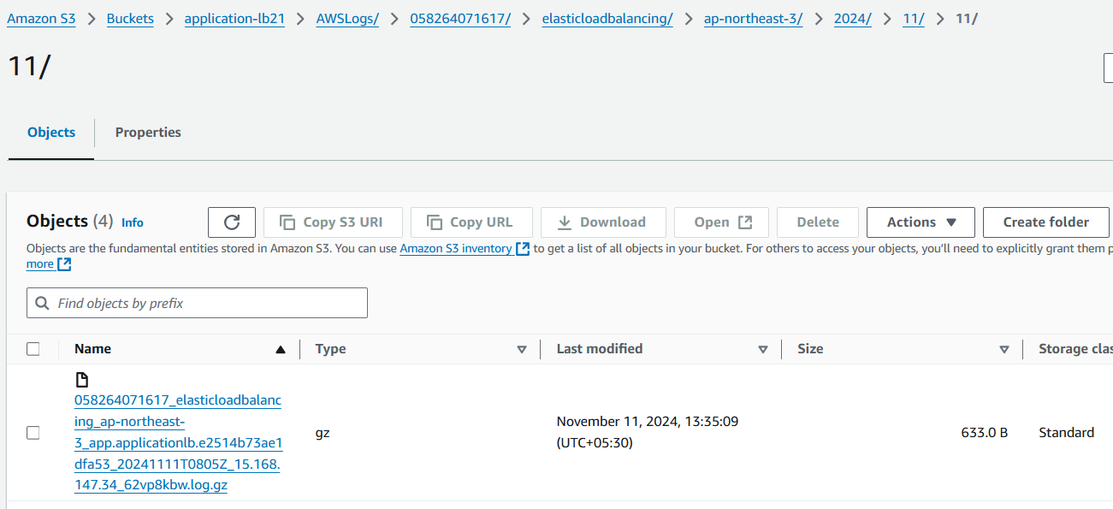

Download the file,we can see the logs

